Each of the following can fill in the blank to print[7, 5, 3]

Platypus…

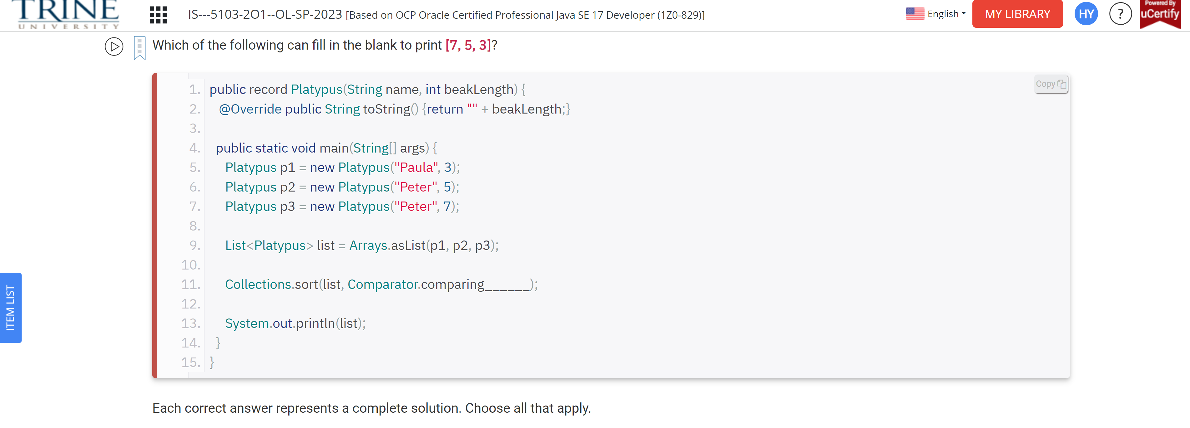

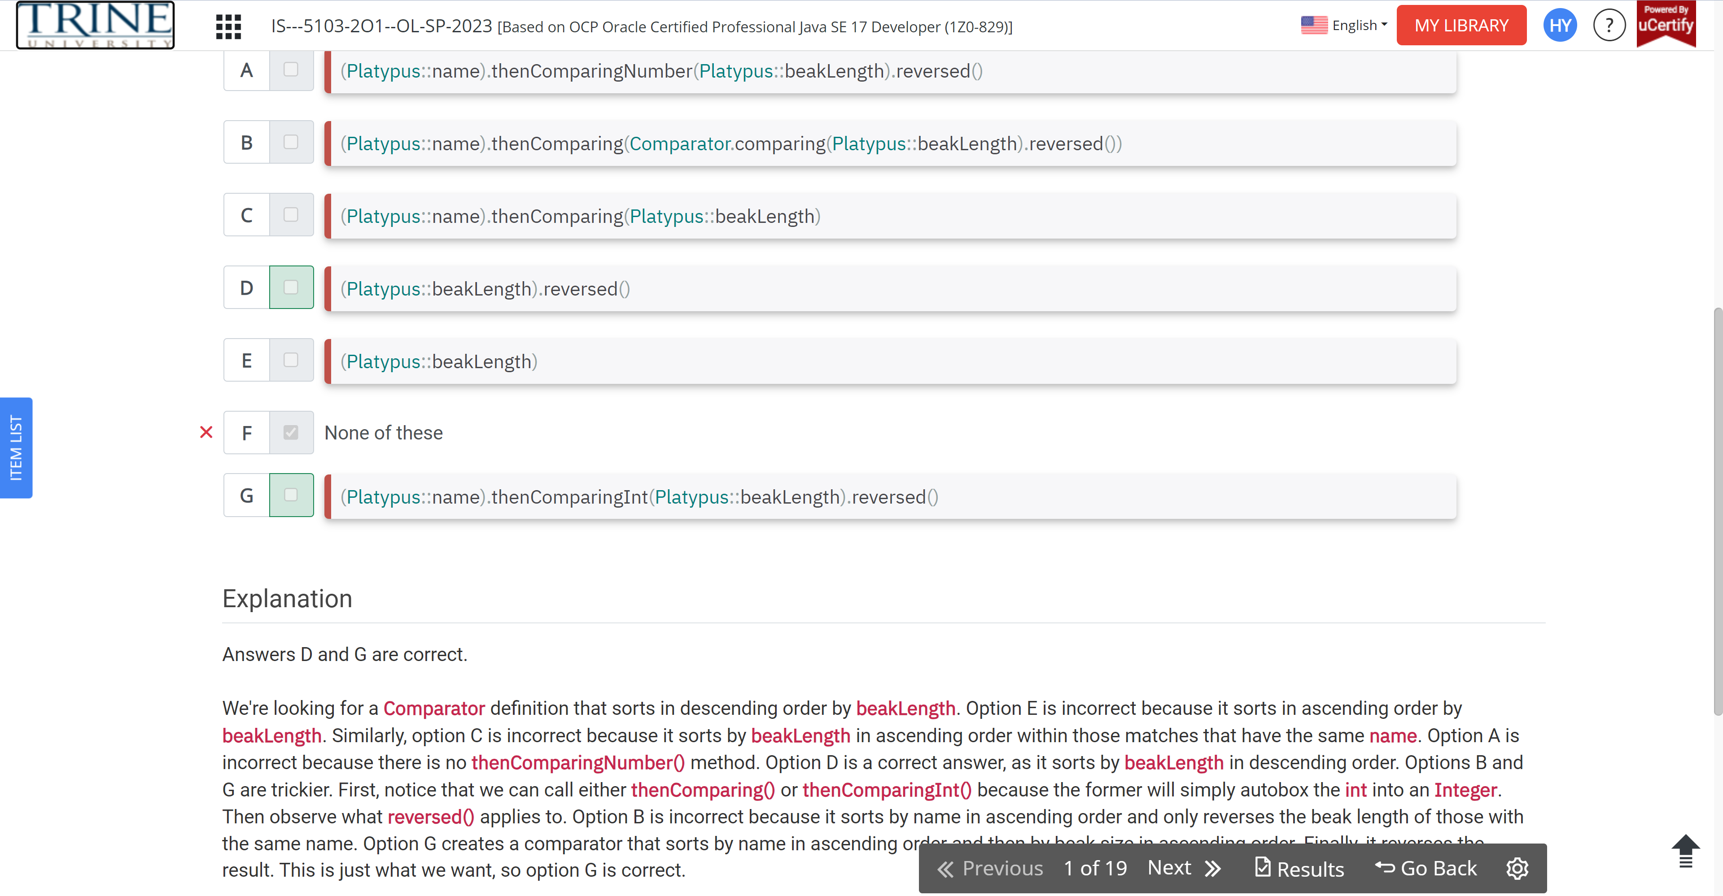

Which of the following will compile when filling in the blank?

Var list = …

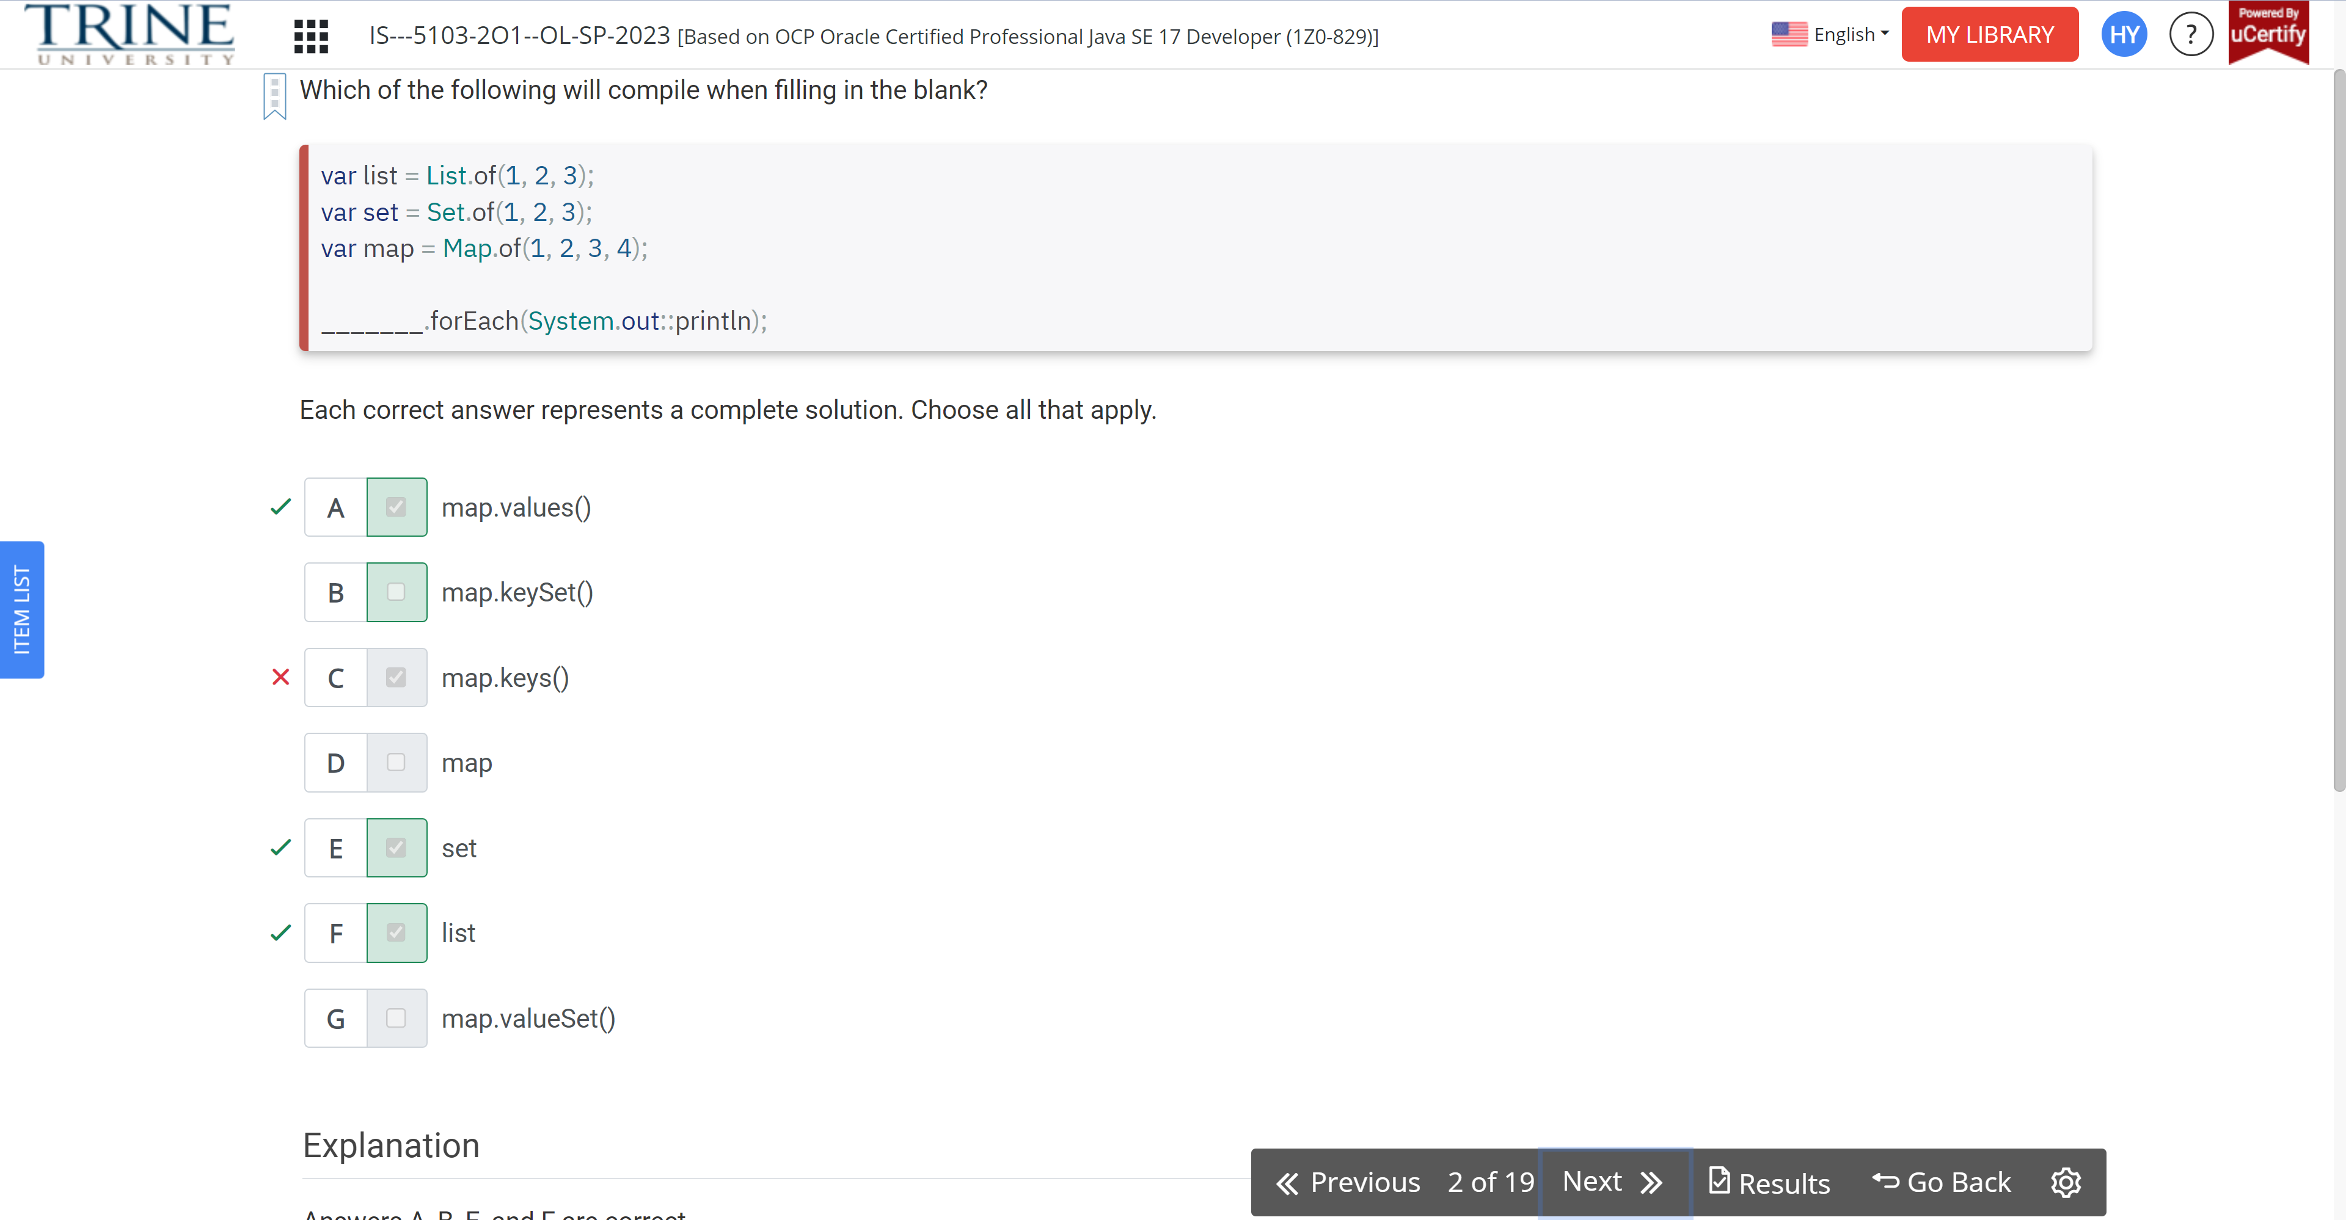

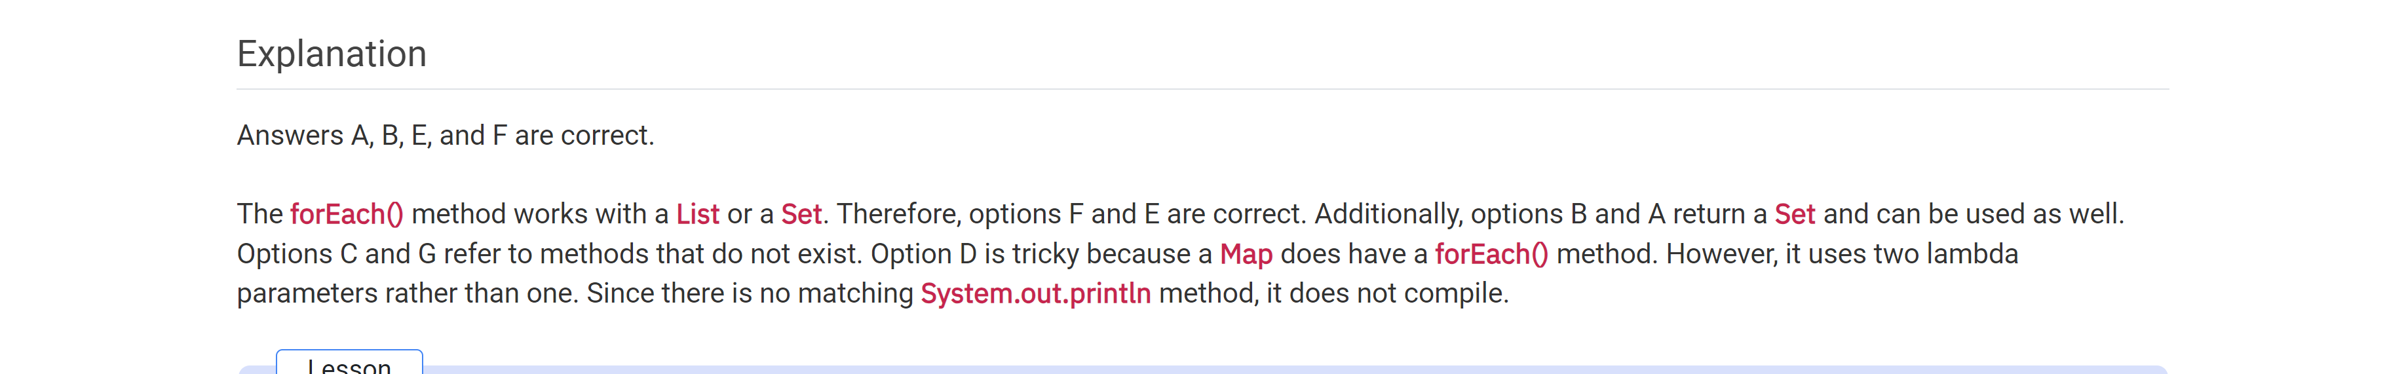

Suppose you need to display…

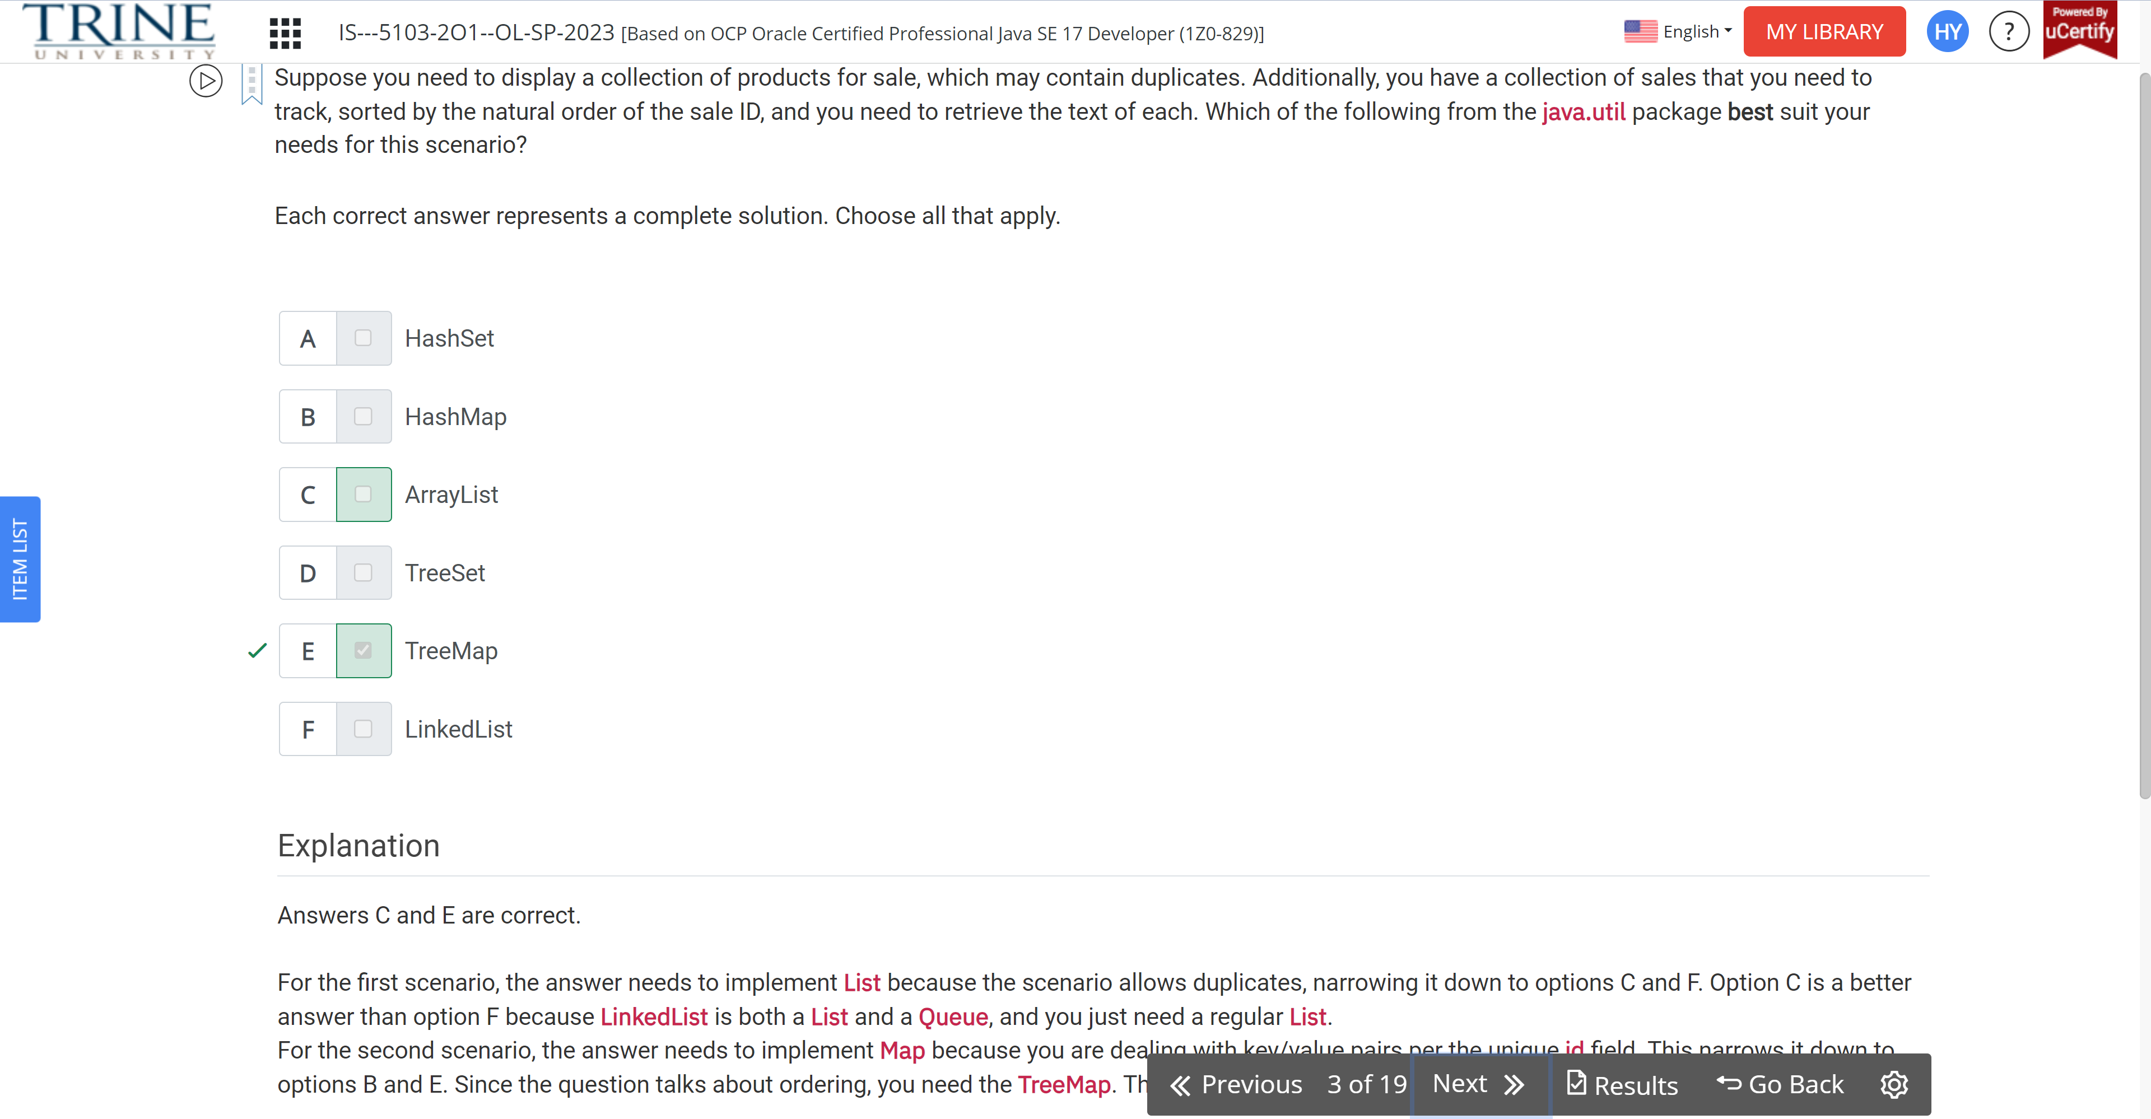

Which of these statements compile/

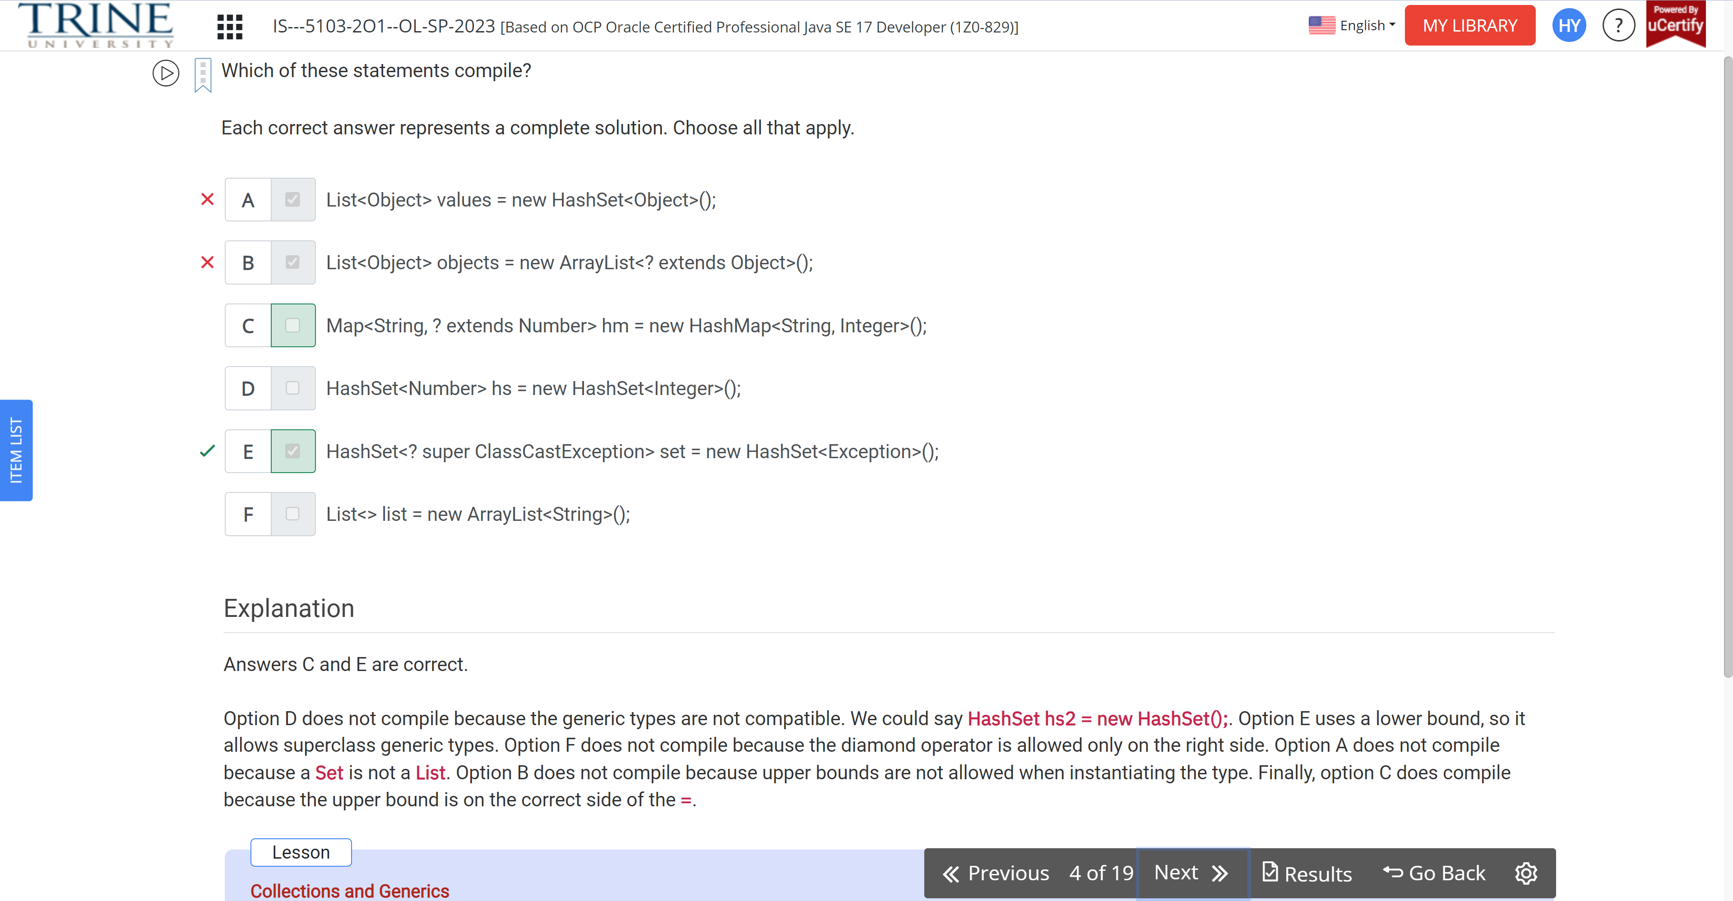

What is the result of the following code?

Var map = …

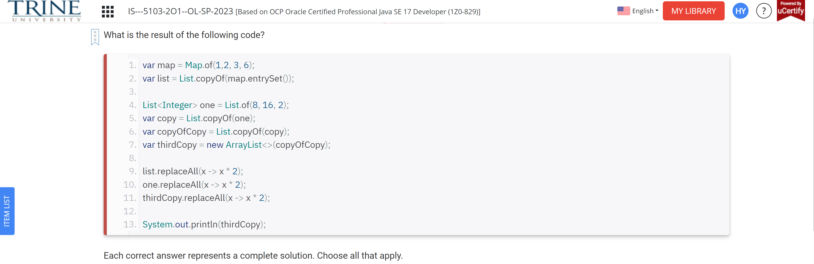

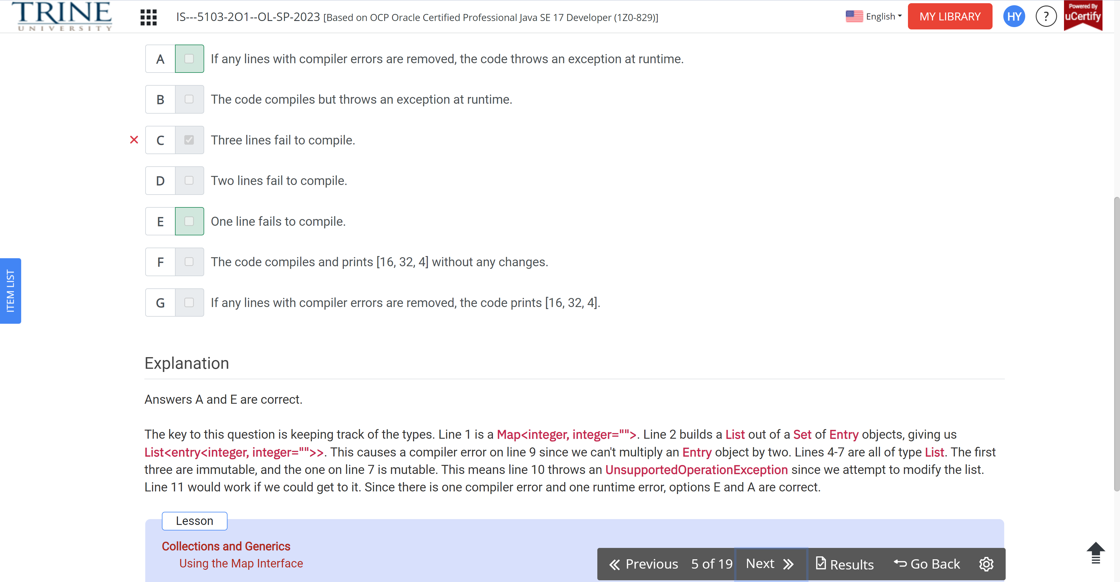

Which of these statements can fill in the blank…Wildcard class

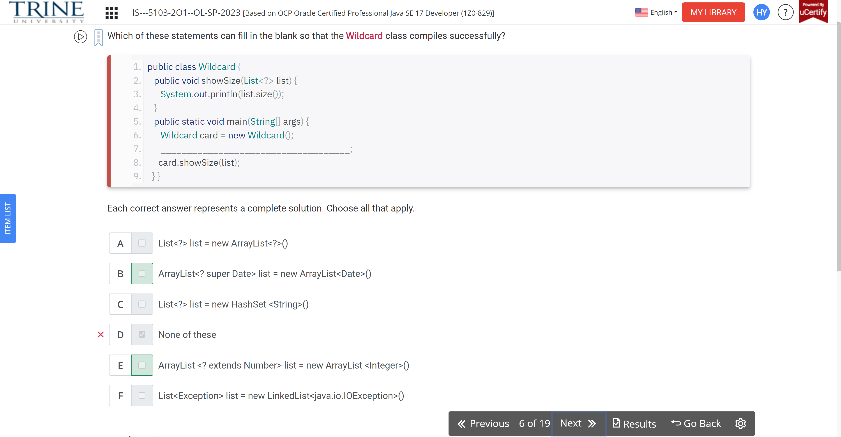

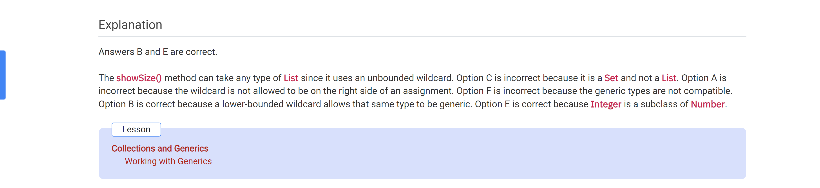

Which of the following are true?

List<?> q = list.of(“”);

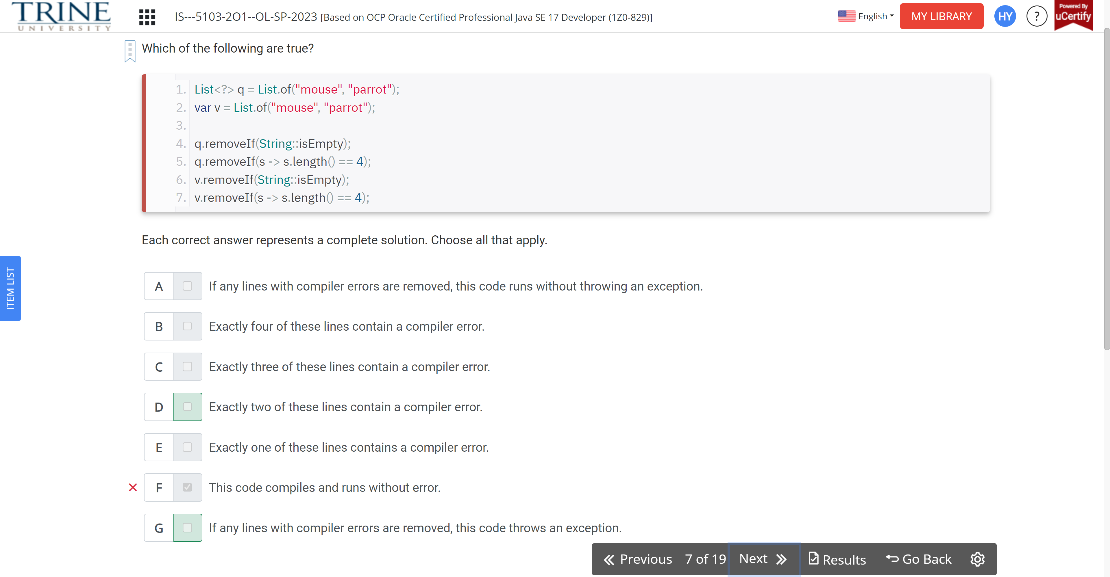

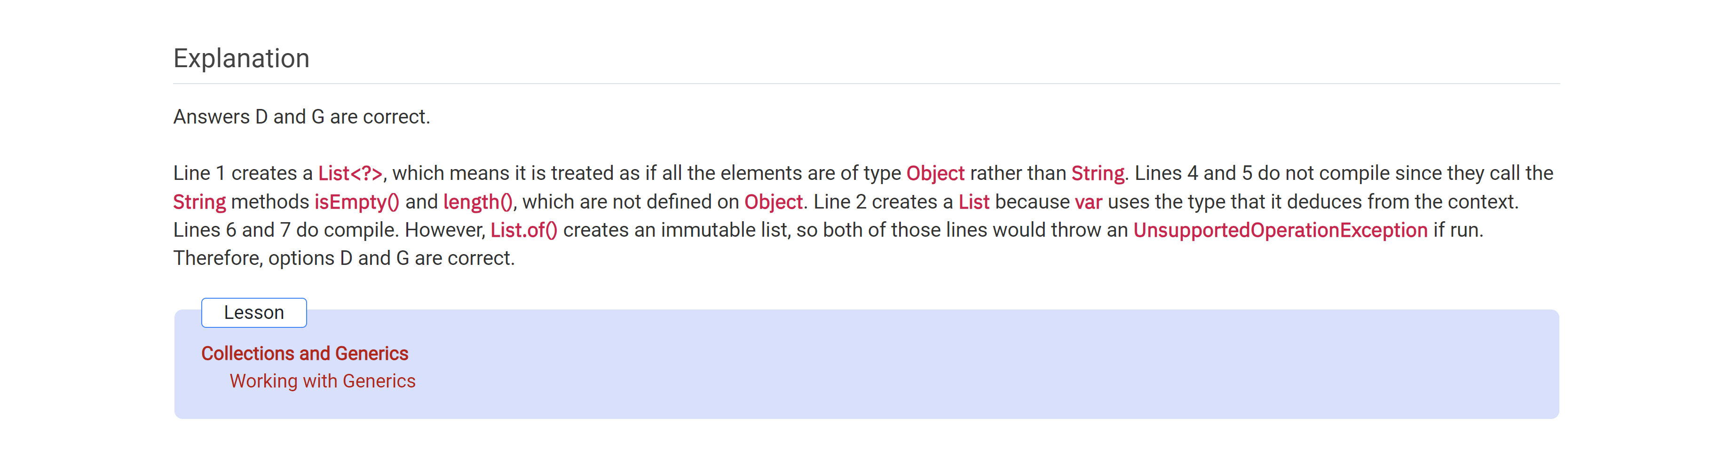

What is the result of the following program?

Mycomparator…

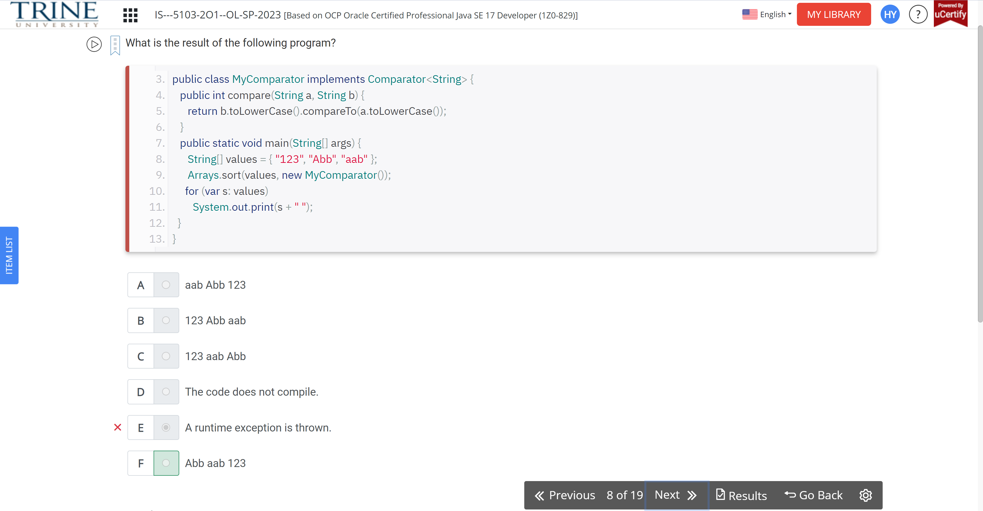

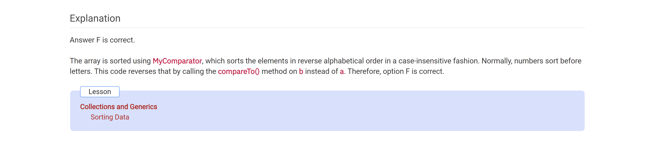

What is the result of the following program?

Public record Sorted

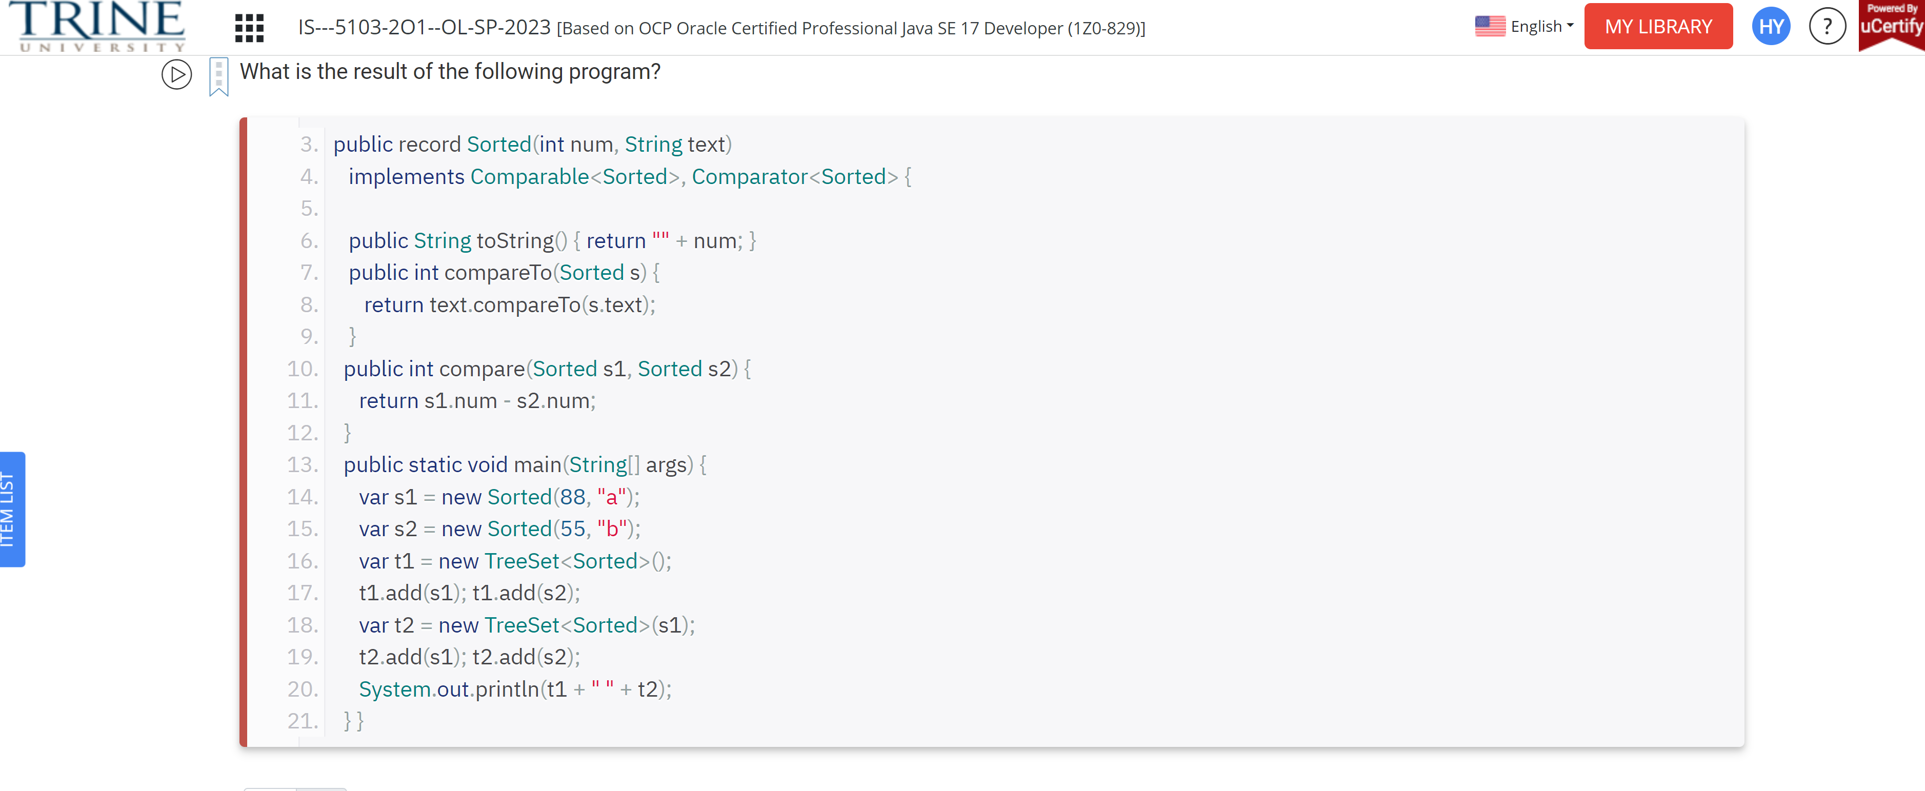

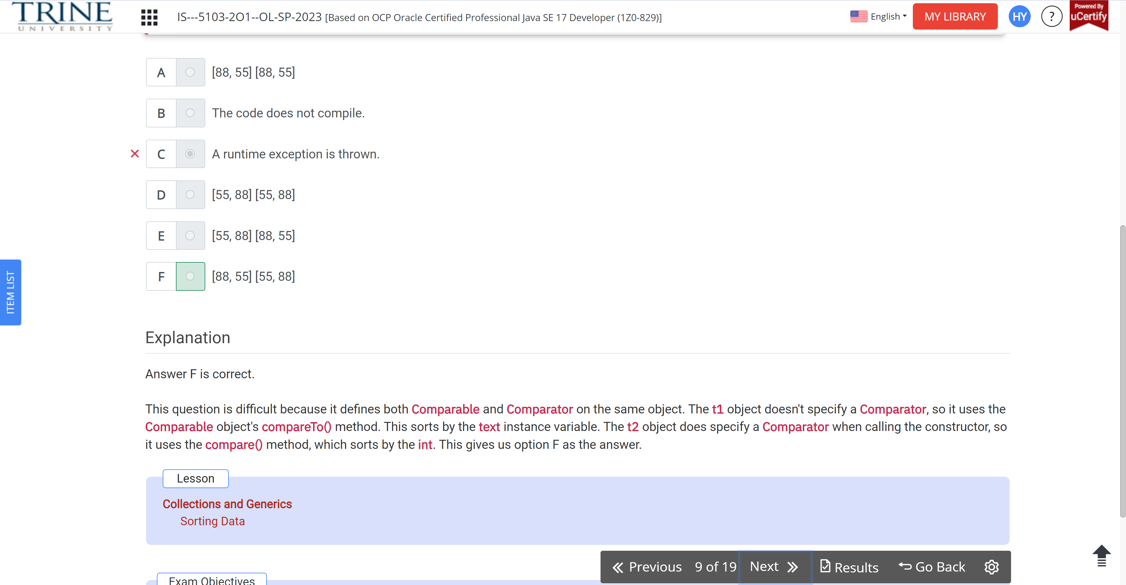

Which options are true of the following code?

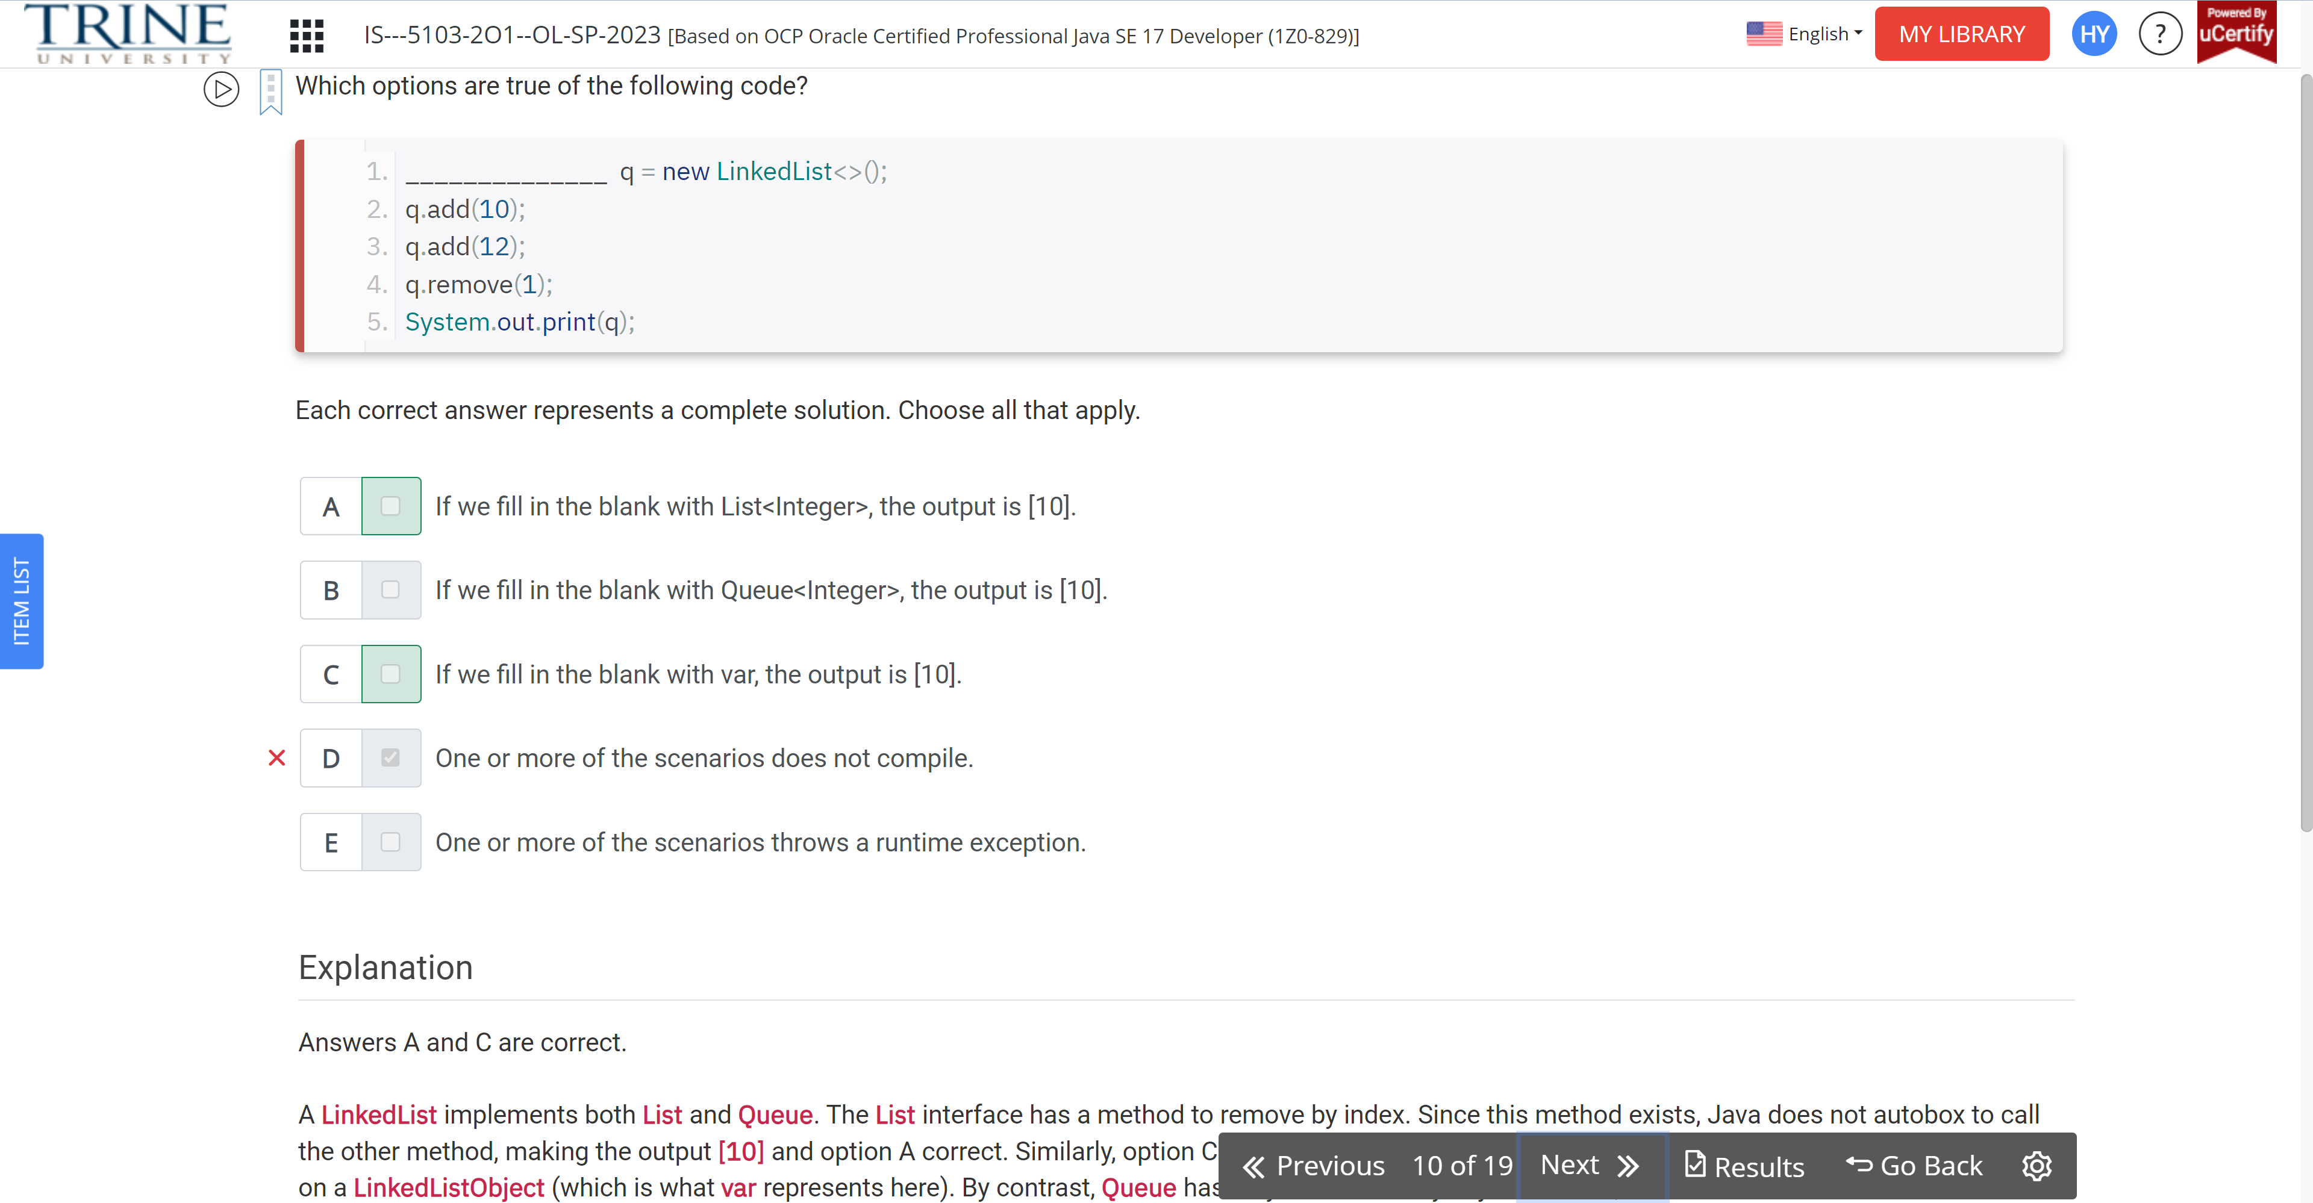

Hairy() … Alpaca …

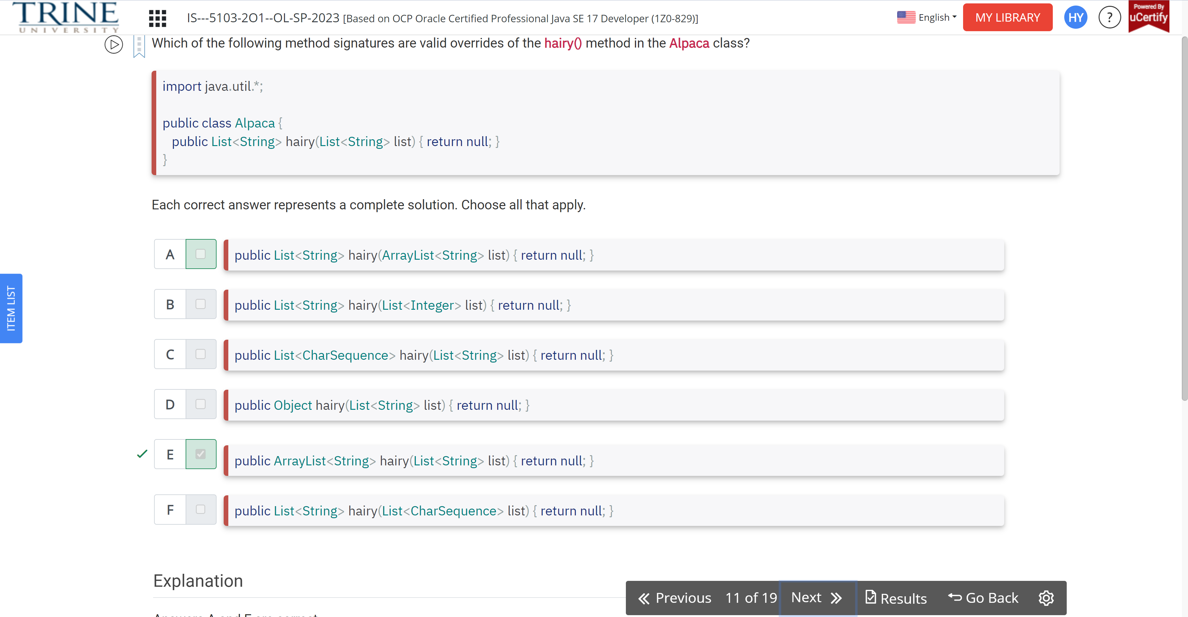

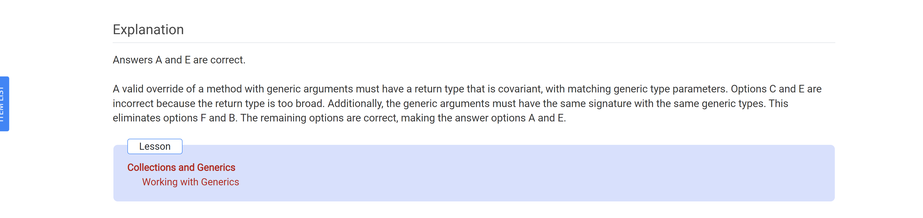

What is the result of the following code?

Map m = ..

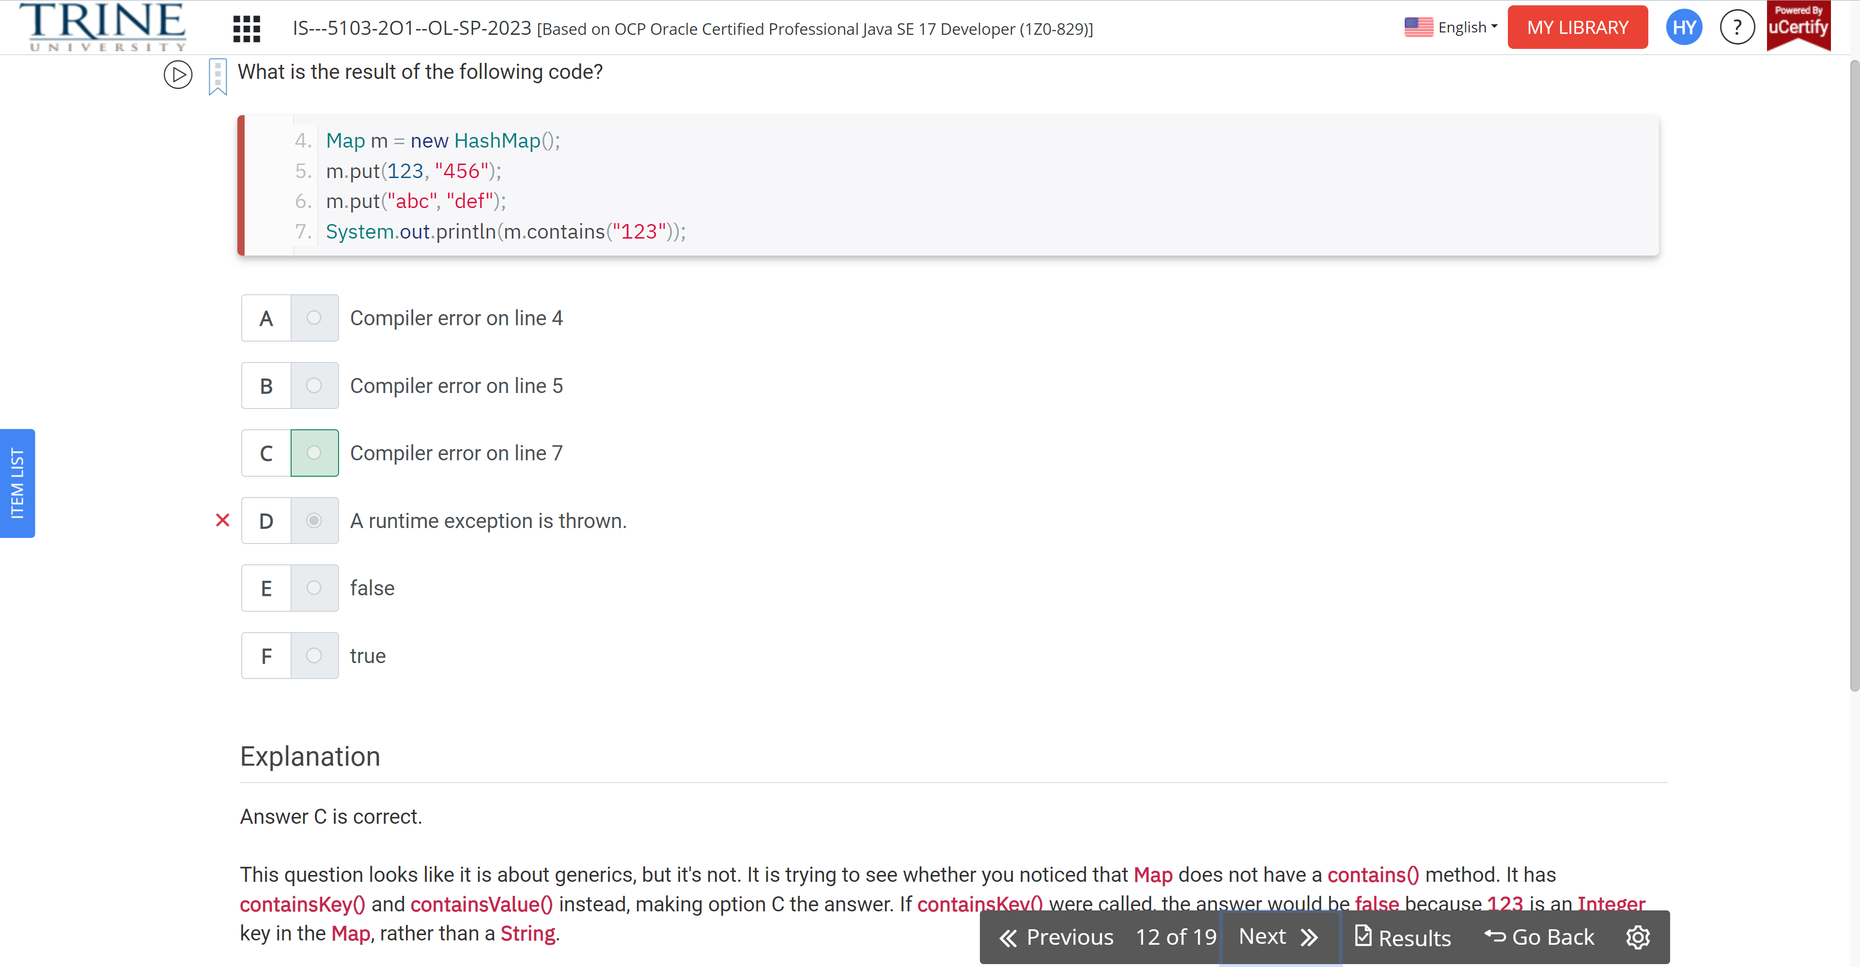

Which of the following lines can be inserted to make the code compile?

Class W {}

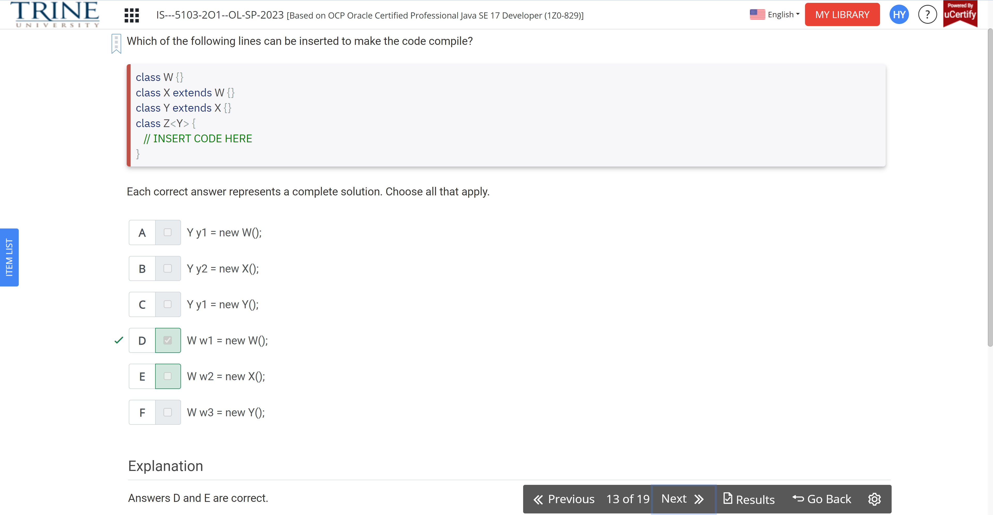

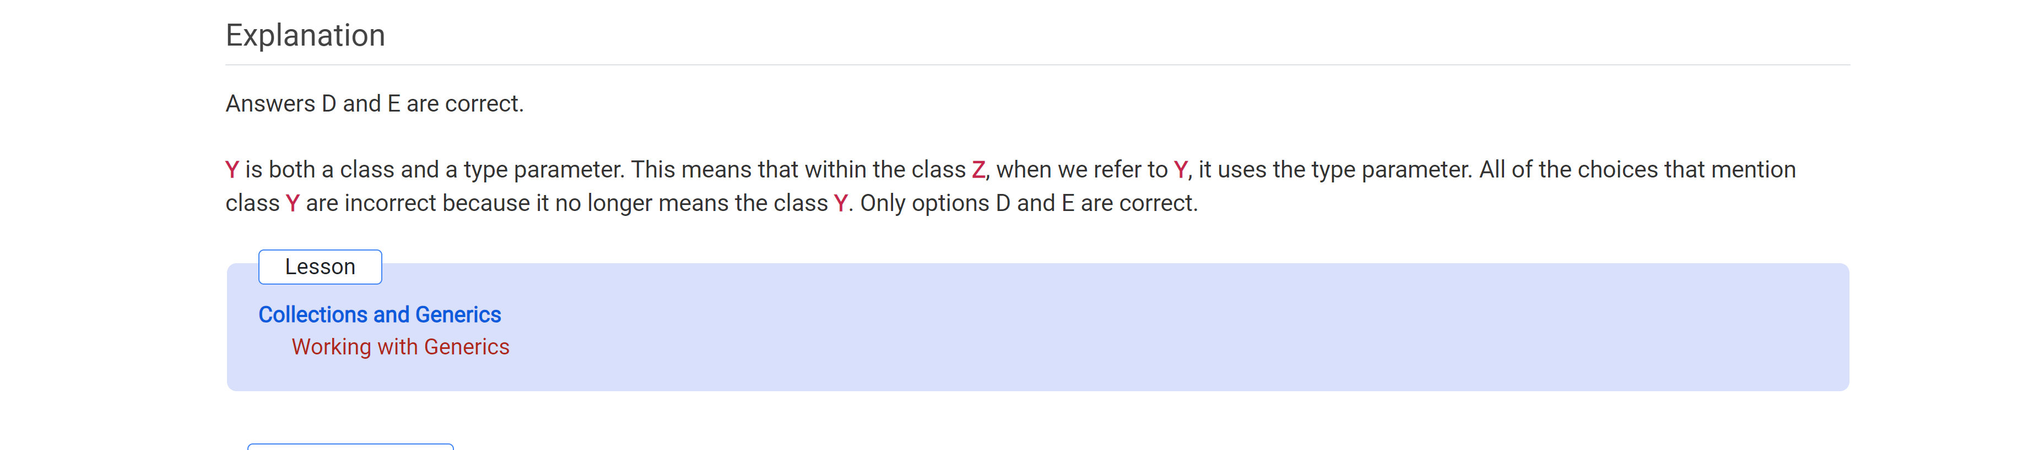

What code change is needed …

Public static T identity (T t) {…

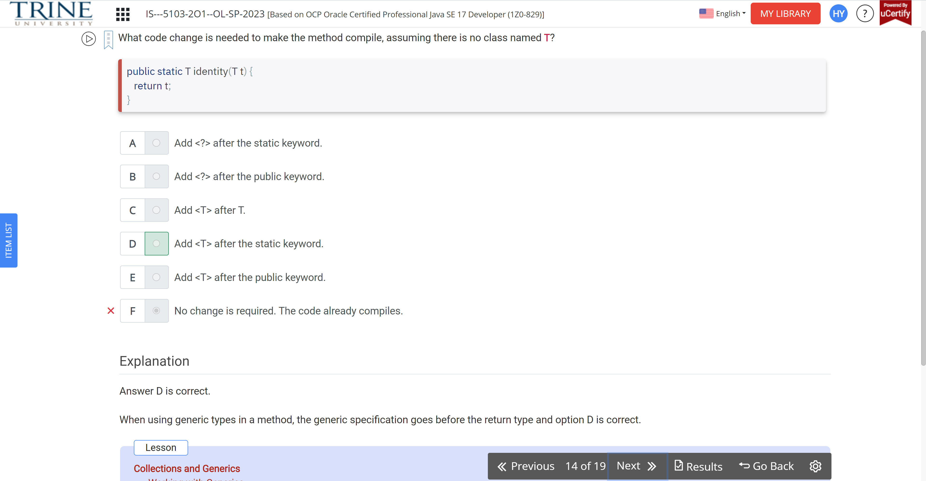

What is the result of the following code?

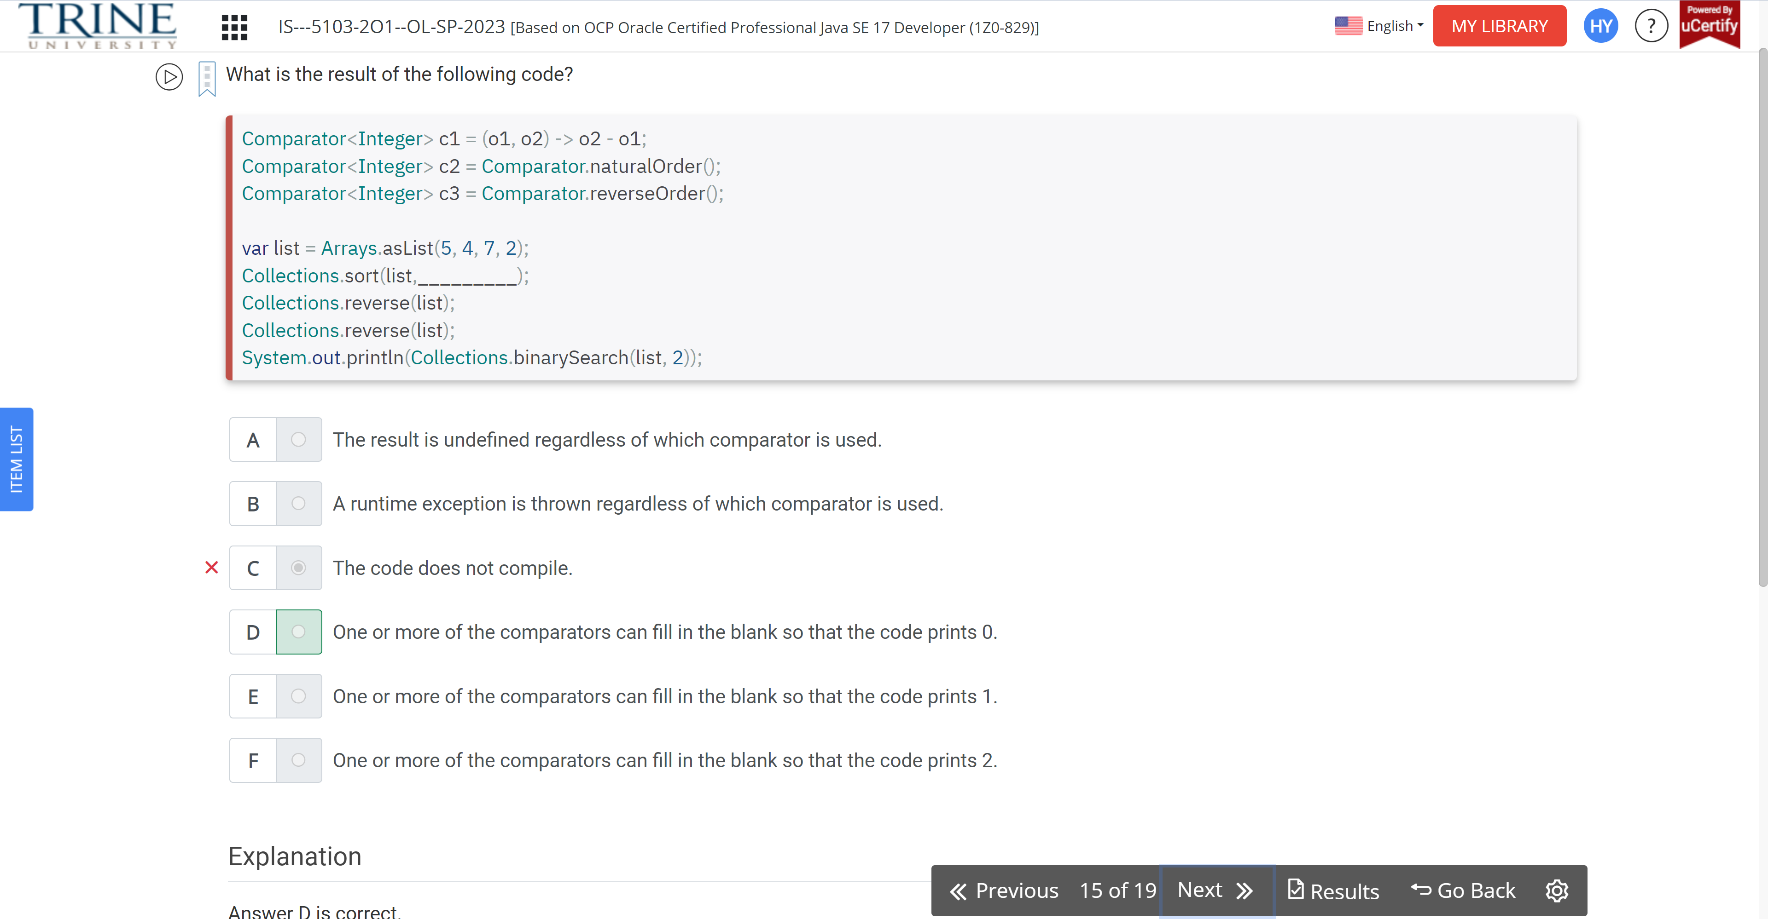

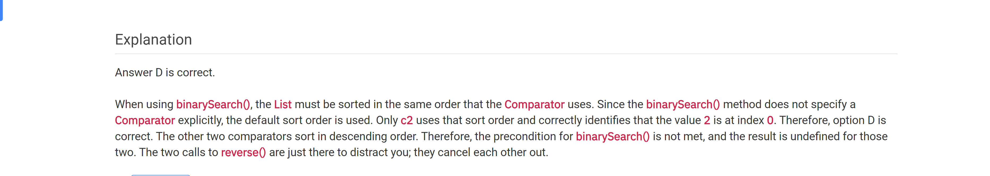

Which of the following statements are true?

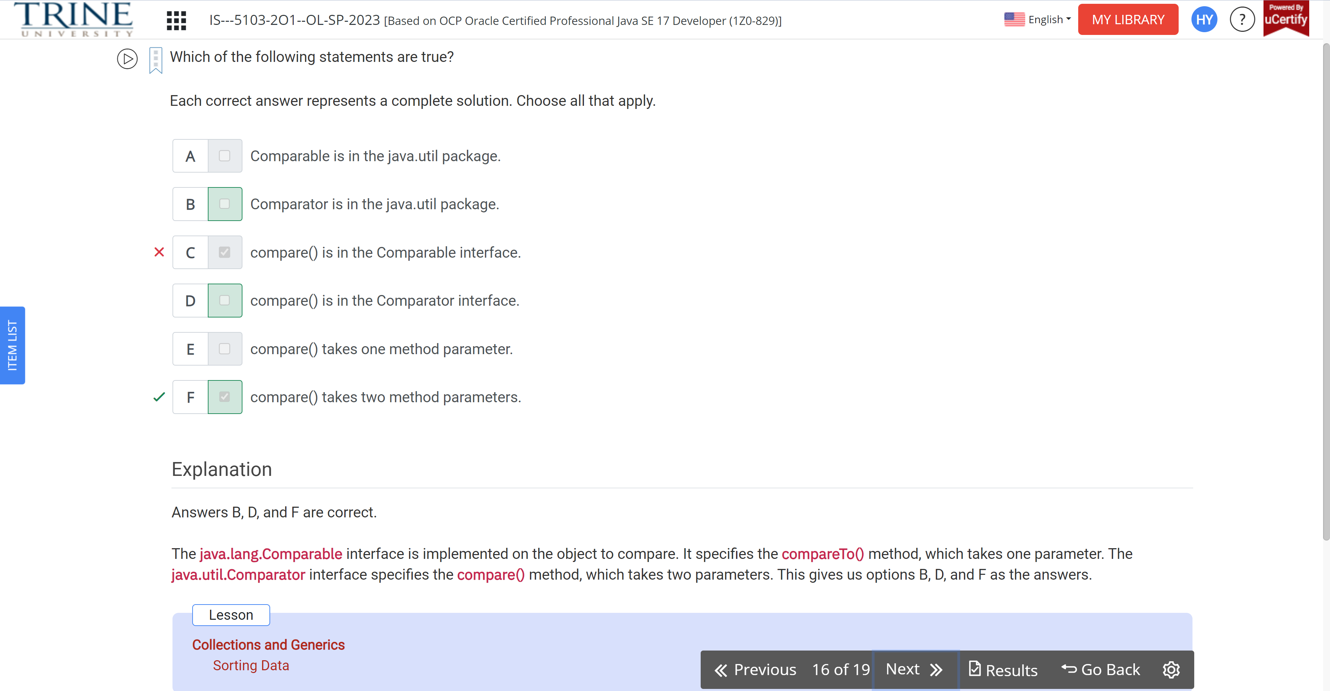

What is the result of the following code?

Public record Hello…

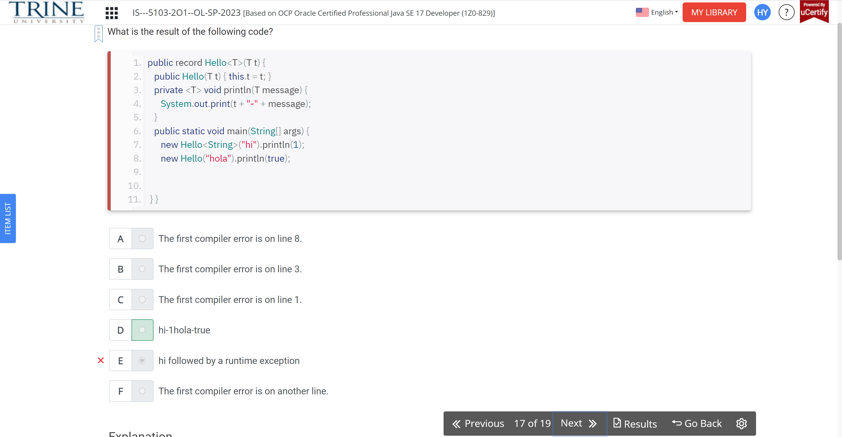

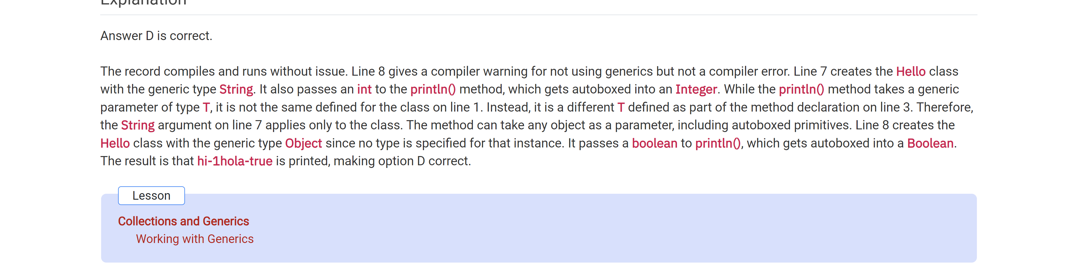

What is the result of the following code?

Var map = new HashMap…

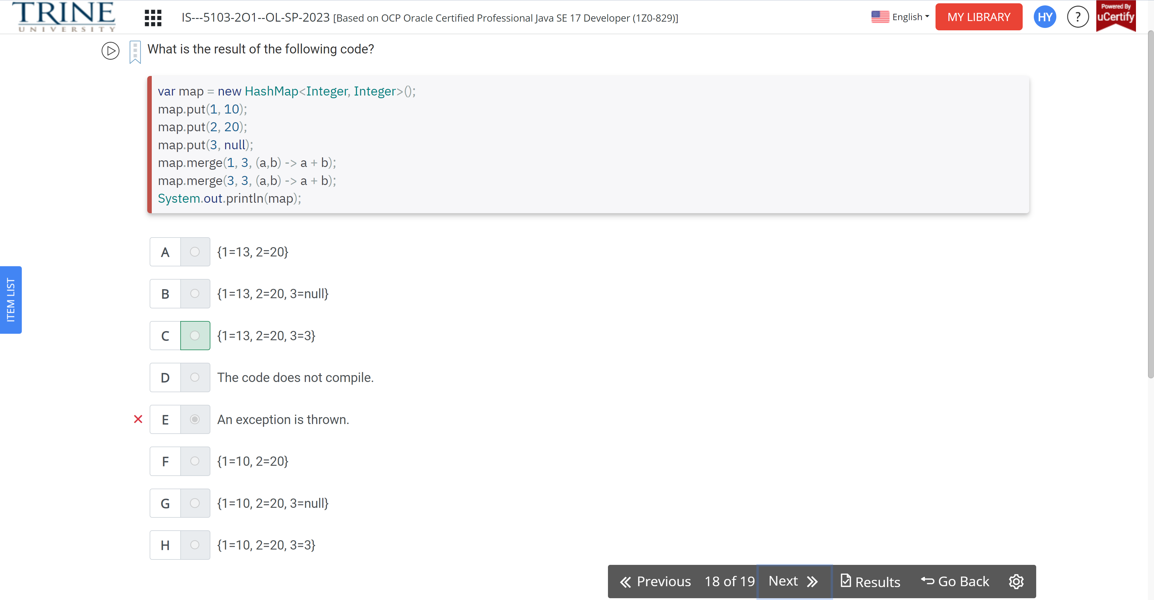

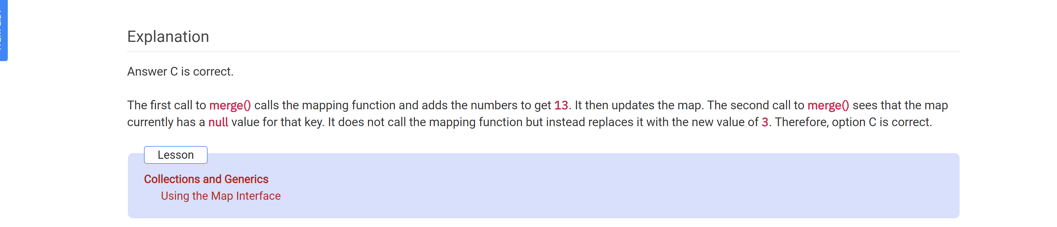

What is the result of following statements?

Var greetings = …

